**How Darknet Markets Are Exploiting the Coronavirus Pandemic**

Note: Information are taken from an article of elliptic.co

At Elliptic, their data team work constantly to gather the latest intelligence on the illicit use of crypto-assets. Key to this is monitoring the rapidly-evolving use of darknet markets, e-commerce platforms that facilitate the trade of various illicit goods and services. Vendors on these sites can post listings for everything from narcotics to stolen credit cards and hacking tools, with payment accepted exclusively in crypto-assets.

These vendors are opportunistic, jumping on any opportunity to supply goods that are difficult to obtain elsewhere. Over the past few weeks they have begun to exploit the opportunities presented by the coronavirus pandemic.

**Masks**

Hundreds of listings have recently appeared on darknet markets for N95 respirator masks. Usually priced at less than $1 each, these masks have been in very short supply and their sale for non-medical use has been restricted. The listings shown below offer N95s in bulk at around $1.75 per mask - a surprisingly low mark-up on retail prices. Compare this to the prices charged by vendors on legitimate marketplaces such as Amazon or eBay, where N95 masks have been listed for sale for upwards of $10 each.

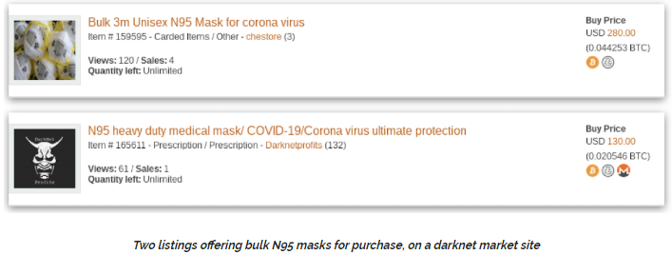

Of course with all darknet market listings posted by pseudonymous vendors, there is a chance that they are fraudulent, and that buyers don’t end up getting what they paid for. Marketplaces therefore employ vendor reputation systems so that buyers can review their purchases and provide useful insights to future buyers. Few reviews have been posted for masks, due to the short period of time that they have been on sale. However what this does reveal is that many of the mask vendors are established, well-reviewed sellers. Many have previously sold narcotics and other illicit goods and services, and have now turned to masks as an additional revenue stream.

Beyond the usual dark marketplaces, a new online shop has launched - dedicated to the sale of masks. The operator of this site claims to be a European wholesaler for hospitals, but believes that “Everybody need a chance to get a Mask for protection - Not only medical employees!”

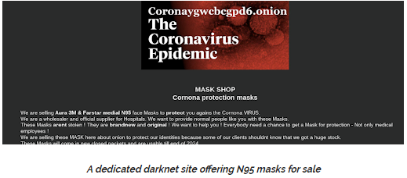

**Diagnostics**

Another critical shortage during the epidemic has been for coronavirus diagnostics. The lack of widespread testing capabilities has been cited as a key reason why certain countries have been particularly hard-hit. And so darknet market vendors have once again stepped in to exploit the opportunity. The listing below offers “COVID-19 test strips”, starting at $92 each.



**Coronavirus “Cures”**

The pandemic has of course created huge interest in potential COVID-19 treatments, with a number of therapeutics and vaccines in development. However none have yet to be proved effective.

However there has been anecdotal evidence that existing drugs such as chloroquine, a malaria treatment, could be an effective treatment for COVID-19. Public interest in this drug has been sparked by repeated comments from US President Donald Trump about the drug’s potential, despite the absence of regulatory approval for its use.

And so we have started to see listings for chloroquine on darknet markets. The listing below refers to the claims made by Donald Trump, and offers a pack of 150 pills for $500.

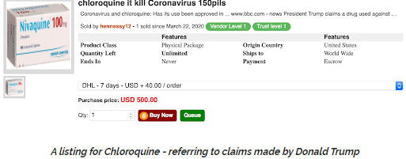

Perhaps even more concerning are listings for coronavirus “cures” that have begun to spring up on certain marketplaces. The product descriptions offer little in the way of details and are certainly scams, but opportunistically prey on people’s likely desperation for treatments.

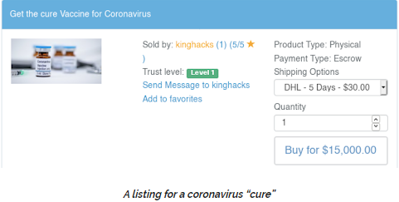

**Narcotics**

For the majority of darknet market vendors it will be business as usual during this global pandemic. In fact as for other online retailers it presents a unique opportunity, and may herald a further shift towards online commerce. Many darknet narcotics purchasers will now be largely confined to their homes, with more free time and fewer opportunities for face-to-face transactions.

Many vendors are using the situation as a marketing opportunity, offering “Coronavirus discounts” or “COVID-19 end of the world special offers”. The listing shown below is for a “Corona Lockdown Survival Pack” The contents? Cannabis and toilet paper.

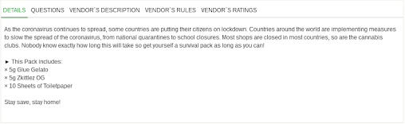

**Coronavirus Hits Darknet Revenues**

The Chainalysis report suggests that darknet markets have suffered substantial declines in revenue following the recent drop in Bitcoin’s value. That’s despite the 70% increase in darknet purchases made with bitcoin in 2019 compared to 2018 that Chainalysis reported in January.

This downturn is unusual because, at least in the past, activity on these platforms was largely unaffected by market volatility—with BTC being used to buy drugs, firearms, and stolen credit card data irrespective of how much the cryptocurrency was worth.

Granted, there are other factors at play here. The pandemic has affected freedom of movement and global supply chains. This has undoubtedly affected the supply of popular substances such as fentanyl—and it’s no coincidence that large volumes of this drug were manufactured in China’s Hubei province, where the pandemic began.

“Perhaps darknet market customers aren’t buying as many drugs given the public health crisis. It’s also possible that vendors slowed down sales during the price drop, out of fear that the Bitcoin they accept one day could be worthless the next,” the Chainalysis report notes.

**Crypto gambling craps out**

It may be fashionable to assume that crypto-based gambling services would have been a big winner during the COVID-19 pandemic, but the Chainalysis research suggests an uptick in demand hasn’t been forthcoming. Volumes of bitcoin flowing into online casinos and gaming sites have been on the decline since March 9— despite many people being stuck at home, it seems few have opted to have a flutter.

The lackluster performance of the gambling sector may not have anything to do with bitcoin’s price, however. Chainalysis says there has long been a weak link between the gambling sector’s revenue and BTC’s value. This basically means that many gamblers would use BTC to place a bet even if the cryptocurrency was at an all-time high, because they “don’t approach gambling rationally or with an expectation of profit, but rather as a way to have fun.”

**Good news for legitimate e-commerce**

On the other hand, online and even (still open) brick-and-mortar merchants providing legitimate goods and services that can accept bitcoin—such as AT&T, Microsoft, game streaming platform Twitch and, indirectly, Amazon—have not met with a fall in purchasing volumes they would have normally expected with bitcoin’s declining value, Chainalysis said.

The company provided a few theories as to what might have shielded merchant services from bigger falls. For one thing, it’s possible that cryptocurrency users are opting to buy essential items through these platforms—products that aren’t currently available from outlets that accept fiat.

For another, demand for merchant services might have enjoyed an uptick because local retailers have had to close because of COVID-19. Finally, recurring payments, such as subscriptions for web hosting, might also be keeping revenues steady as other income streams dry up.

Warning that this is no ordinary Bitcoin price drop, the Chainalysis report added: “It’s a one-of-a-kind market event brought on by an unprecedented public health crisis. The question for cryptocurrency businesses is whether or not they’ll be able to return to their previous transaction levels and if their customers’ usage patterns will return to normal.”